CHINESE FLAGSHIP SECONDARY CURRICULUM
LEVEL 4 - AN INTERCONNECTED WORLD

Unit 1: Career and Family
Integrated Performance Assessment

Novice Novice Novice Intermediate Intermediate Intermediate
Low ➔ Mid ➔ High ➔ Low ➔ Mid ➔ High➔

Learning Targets:

- I can express my opinion about how to get an ideal future job.
- I can demonstrate my understanding of a job-seeker website.
- I can compose a job application for a job.

- I can discuss the family values and generation gap with peers.
- I can converse with peers to compare the Chinese family values with the American family values.
- I can create a blog to share my ideas of how to resolve conflicts between a friend and his/her parents regarding choosing a college major and future career.

Task Overview

One of your best friends is Chinese. As a senior in high school, he’s looking for a part-time job to earn some money and gain some work experience which should benefit him in his future job application. Meanwhile, he is trying to choose a major that he is passionate about, but that has caused conflicts with his parents’ beliefs and hopes. They believe a good major reflects educational achievement and will lead him to a decent career with higher compensation and social status. They hope he will stay close to them when he attends college and even after he gets employed in order to maintain family interdependence. Your friend is the only child in the family, obedient and respectful . However, he got into a heated argument with his parents this time. He is glad to be able to discuss these topics with you on a blog posting and is anxious to hear your response. His parents are also curious to hear your thoughts on these subjects.

Interpretive Reading Task (Reading text, plus comprehension questions):

Authentic information about a job-seeker website

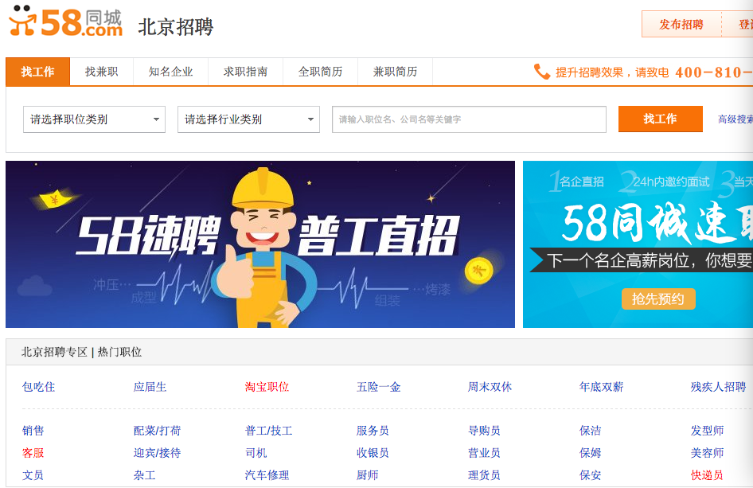

1.What kind of website is this?
2.What city provides jobs?
3.In which category you can upload your resume?
4.What kind of occupations can you find?
5.Which job is suitable to you? Why?

Extension Assessment:
A. Read the following stories and answer the comprehension questions:
两个尊老爱幼的小故事

Story 1:
- What did the dentist do as soon as a wealthy man and his mother walked into the clinic?
- Why did the mother choose the cheapest dentures?
- Where did the mother keep her money?
- Why did the clinic people get so outraged towards the wealthy son?
- Why did the son return to the clinic by himself?
- What kind of character does the son?

Story 2:

- Why did the mother called her daughter at 5:40 a.m. to wake her up?
- Why didn't the driver wait until the old couple got on the bus?
- Which paragraph tells you the main idea of this story?
- How would you understand this proverb?
父亲给儿子东西的时候，儿子笑了。
儿子给父亲东西的时候，父亲哭了。

Interpersonal Listening and Speaking Task:

You are invited to your Chinese friend’s home and his parents ask you what is your favorite career.

You and your friend compare Chinese family values with American family values.

On the way to the bus stop, you and your Chinese friend discuss:
- how the generation gap is manifested in your families;
- what you could do to reduce the generation gap.

Interpersonal and Presentational Writing Task:

Your Chinese friend sends you an email about an ideal job and you need to reply his email.
真没想到，我一下子找到了两份工作机会。一个是在学校旁边的一家肯德基餐馆工作，虽然工资不高，但是很轻松，就是卖卖快餐。另一个是在离学校较远的一家超市当收营员。工资比较高，不过工作负担太重。你觉得我应该选择哪一份工作？为什么？另外，请你告诉我，你今年暑假计划申请什么工作？（这份工作跟你将来想做的职业有什么关系？）

Your Chinese friend posts a blog about family values and generation gap and you need to post a response to him.
最近我在将来找什么工作的事情上跟父母发生了争吵。我想选择当音乐家或者艺术家，所以想申请几所大学的艺术专业，可是父母觉得学艺术或者音乐没有前途，毕业后难以找到好的工作。他们期望我能学建筑专业，觉得建筑专业的毕业生找到高薪工作的机会多一些。我知道父母说得话有道理，但是我想选择跟自己爱好相关的专业。你们觉得我该怎么办？另外，你们决定选什么专业？你们计划将来选择什么职业？

http://blog.sina.com.cn/s/blog_5223ef410100ccls.html

(Rubrics)

Presentational Speaking Task:

Your Chinese friend’s parents wants to know your ideal career and Top 10 jobs in the United States. You decide to make a youtube video about this topic to show them.

